**`ROLE OF NOCTURNAL LEPIDOPTERA IN AGRICULTURE**

Navneet Singh *1, Dipayan Mitra 2, Rajesh Lenka 3, Pallab Chatterjee 4

**INTRODUCTION:**

Pollination is the most exclusive and fundamental process for reproduction of plants. And by facilitating plant reproduction, pollination controls world’s plant diversity (Ollerton, 2017). Moths are major nocturnal pollinators of flowers (Macgregor et al., 2015). Nocturnal macro-moths are extremely species rich flower visitor and highly neglected throughout the years in pollination study. It plays an important role in pollination because of its complex pollination network(Walton et al., 2020). Crop pollination by wild pollinators has an immense role in modern agriculture (Martins & Johnson, 2009). Almost 90/% of total pollination is carried out by animals. Non bee insects provide 25-30 % of total pollination of crop plants (Rader et al., 2016). In agricultural landscape macro moths provides a unique and complex pollen transport links which makes them a vital player in overall plant–pollinator network in agro ecosystem (Walton et al., 2020). Many crop plants are dependent on animals for pollination (Willmer, 2011). Nocturnal lepidoptera plays a major role in pollination of Lowbush blue berry and *Aquilaria sinensis* (Thymelaeceae) (Chen et al., 2016; Cutler et al., 2012). In tropics of East Africa hawk moth play a major role in pollination of bottle gourd *(Lagenaria siceraria,* Cucurbitaceae*)* and papaya (Cacicaceae) (Martins & Johnson, 2009; Morimoto et al., 2004).Study on pollination by Lepidoptera in tropical and sub tropical regions not much studied till date (Rosas-Guerrero et al., 2014). Floral preferences are different between butterflies and hawk moths and this phenomena has helped to understand the evolution of flowers in tropical regions (Mertens et al., 2021). Pollination of different crop plants, medicinally and economically important plants have been studied in agricultural landscape, rain forests throughout the globe. Study on four species of Cucurbitaceae in China (Lu et al., n.d.) has shown some importance paths in crop pollination study and role of nocturnal lepidoptera in it. Sphingidae mainly prefers long spurred, light coloured flowers which are easily seen at night. On the other hand settling moths mainly prefers dark and vibrant coloured flowers. Lepidoptera placed in 3rd position among other insects in case of pollination process. Apart from bees hawk moths play an important role in pollination. In our study we have established a network which indicates the relative relation of different crop, fruit and economically important plant species with moth species of different families.

***FIELD WORK:***

1. ***Collection of Moths and isolation of proboscis***

Moth specimens were collected from light trap using mercury vapor lamp (125 wt.) and vertical sheet in different altitudinal gradients. Moths were killed using Ethyl acetate in individual small containers to eliminate the pollen contaminations. Then proboscis of each moth has been separated and kept in vials with code number. After that the moths were kept in individual envelop with proboscis code number. Later moths have been kept inside fridge until proper preservation according to modern Lepidopterology.

1. ***Collection of polleniferous material***

Plant samples have been collected from different regions of Arunachal Pradesh. After collection of plants samples are preserved in drying paper for further identification with some flowering part and rest of the flowers are dissected by surgical needle to collect anthers. After collection of anthers from each type of flowers samples are preserved in 9ml cryochill vials with (1:1) phenol: glycerin solution.

under DP–25 digital camera under 40X magnification. For some proboscis of those moths which shows higher rates of interaction, we have followed double staining method [1 mL Malachite green (1% solution in 95% alcohol) 50 mL Distilled water 25 mL Glycerol 5 mL Acid fuchsine (1% solution in water)] to differentiate aborted and non-aborted pollens in the total pollen load (Peterson *et al.,* 2010).

. ***LABORATORY WORK:***

1. ***Processing of polleniferous material***

Anthers samples have been macerated by acetolysis method and made permanent slides as references. The polleniferous material (flowers/stamens) was collected during the field work in and around the light tapping locations to prepared pollen reference slide for accurate identification of pollen in the studied moth samples. The material was crushed with glass rod and mixed with distilled water. Similarly, the proboscis of the collected moth samples was washed through distilled water. Thereafter, both the samples were taken in 10 ml standard plastic centrifuge tube and centrifuged, and then water was decanted off. Again the decanted material were centrifuged with glacial acetic acid (GAA) and further decanted off. After that, the material was again centrifuged with acetolysis mixture (9:1 acetic anhydrate and concentrated, H2SO4) and keep in a hot water bath for about 2 minutes (Erdmann 1954).

***(d)*** ***Light microscopy of collected pollens from proboscises of moths***

Proboscises of each moth sample has been placed upon a glass slide and incubated with few drops of (1:1) phenol; glycerin solution for 1–2 minutes for relaxation of proboscis. Then one to two drops of basic fuchsine dye have been added to proboscis and slides are mounted with cover slips and sealed with nail varnish. Photographs have been taken with **Nikon *50i***microscope under DP–25 digital camera under 40X magnification. For some proboscis of those moths which shows higher rates of interaction, we have followed double staining method [1 mL Malachite green (1% solution in 95% alcohol) 50 mL Distilled water 25 mL Glycerol 5 mL Acid fuchsine (1% solution in water)] to differentiate aborted and non-aborted pollens in the total pollen load (Peterson *et al.,* 2010).

1. ***Scanning Electron Microscopy of collected pollens from proboscises of moths***

Isolated proboscises are dehydrated with serial alcohol gradation (30%, 50%, 70%, 80%, and 90%). After gradual dehydration proboscises are placed on aluminum stub for gold sputter coating and visualized under **ZISS EVO 18** scanning electron microscope.

***(e) Identification of pollens***

Pollens are identified from two website i.e. The global pollen project (<https://globalpollenproject.org>) and Paldat *(*www.paldat.org). Two text book i.e. Text book of Palynology and Illustrated pollen terminology have been also used for identification.

***(f) Statistical Analysis***

Bipartite network between moth and plant species and PCA analysis have been done by ‘bipartite’ and ‘FactoMineR’, ‘factoextra’ package in R (PCA - Principal Component Analysis Essentials - Articles - STHDA, n.d.; RStudio 1.1.463, n.d.)

***RESULT:***

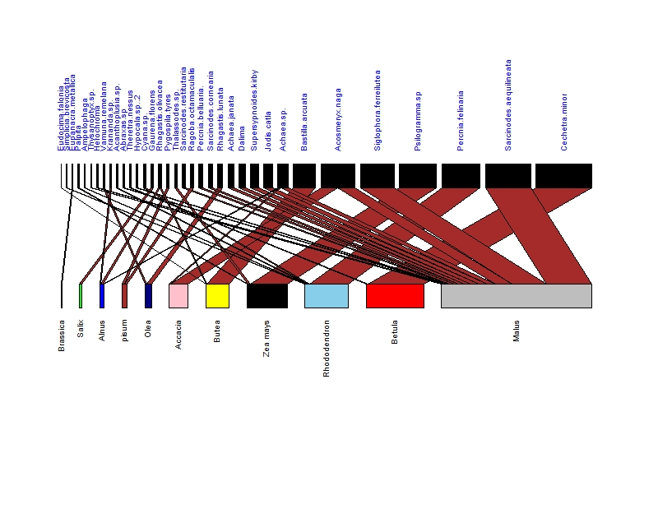***Bipartite network of crop plant and moth species***

Bipartite network of moth-plant interaction along the different elevational gradient of Sikkim, Arunachal Pradesh and North Bengal. The upper nodes represent the flower visiting and pollen carrying moth species and different colours of lower nodes represent plant species from 9 families. Network is constructed on the basis of width of each lower node, upper node and connecting links which represents total number of pollen grains of particular plant species, pollen carrying capacity of individual moth species and number of pollen grains of particular plant species carried by a single moth species respectively.

***Variables PCA***

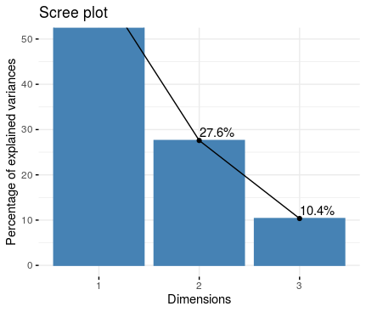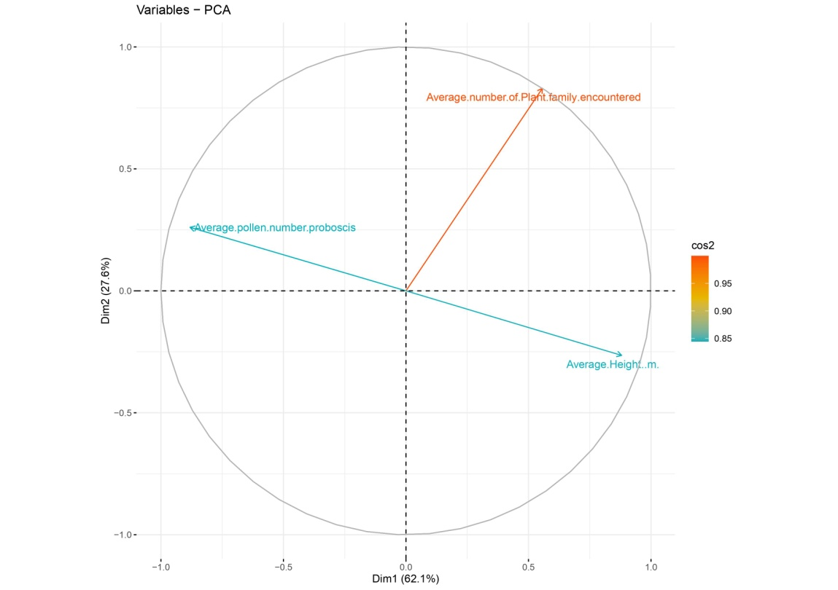

**Scree plot**

Principle component analysis have been done to find out the relationship between three variable i.e a. Average number of plant family encountered, b. Average pollen number/ proboscis, c. Average height. Variables b and c are negatively correlated and all 3 variables are perfectly represented because cos2 value of these variables high. Colour representation shows this representation. This PCA analysis illustrates the relationship between moths 5 families and plant species of 9 families depending upon 3 variables.

***DISCUSSION***

**REFERENCES:**

Chen, G., Liu, C., & Sun, W. (2016). Pollination and seed dispersal of Aquilaria sinensis (Lour.) Gilg (Thymelaeaceae): An economic plant species with extremely small populations in China. *Plant Diversity*, *38*(5), 227–232. https://doi.org/10.1016/j.pld.2016.09.006

Cutler, G. C., Reeh, K. W., Sproule, J. M., & Ramanaidu, K. (2012). Berry unexpected: Nocturnal pollination of lowbush blueberry. *Canadian Journal of Plant Science*. https://agris.fao.org/agris-search/search.do?recordID=US201600200350

Lu, Q.-B., Liu, C.-Q., & Huang, S.-X. (n.d.). Moths pollinate four crops of Cucurbitaceae in Asia. *Journal of Applied Entomology*, *n/a*(n/a). https://doi.org/10.1111/jen.12871

Martins, D. J., & Johnson, S. D. (2009). Distance and quality of natural habitat influence hawkmoth pollination of cultivated papaya. *International Journal of Tropical Insect Science*, *29*(3), 114–123. https://doi.org/10.1017/S1742758409990208

Mertens, J. E. J., Brisson, L., Janeček, Š., Klomberg, Y., Maicher, V., Sáfián, S., Delabye, S., Potocký, P., Kobe, I. N., Pyrcz, T., & Tropek, R. (2021). Elevational and seasonal patterns of butterflies and hawkmoths in plant-pollinator networks in tropical rainforests of Mount Cameroon. *Scientific Reports*, *11*(1), 9710. https://doi.org/10.1038/s41598-021-89012-x

Morimoto, Y., Gikungu, M., & Maundu, P. (2004). Pollinators of the bottle gourd (Lagenaria siceraria) observed in Kenya. *International Journal of Tropical Insect Science*, *24*(1), 79–86. https://doi.org/10.1079/IJT20046

Ollerton, J. (2017). Pollinator Diversity: Distribution, Ecological Function, and Conservation. *Annual Review of Ecology, Evolution, and Systematics*, *48*(1), 353–376. https://doi.org/10.1146/annurev-ecolsys-110316-022919

*PAST*. (n.d.). LO4D.Com. Retrieved May 25, 2021, from https://past.en.lo4d.com/windows

*PCA - Principal Component Analysis Essentials—Articles—STHDA*. (n.d.). Retrieved June 6, 2021, from http://www.sthda.com/english/articles/31-principal-component-methods-in-r-practical-guide/112-pca-principal-component-analysis-essentials/

Rader, R., Bartomeus, I., Garibaldi, L. A., Garratt, M. P. D., Howlett, B. G., Winfree, R., Cunningham, S. A., Mayfield, M. M., Arthur, A. D., Andersson, G. K. S., Bommarco, R., Brittain, C., Carvalheiro, L. G., Chacoff, N. P., Entling, M. H., Foully, B., Freitas, B. M., Gemmill-Herren, B., Ghazoul, J., … Woyciechowski, M. (2016). Non-bee insects are important contributors to global crop pollination. *Proceedings of the National Academy of Sciences*, *113*(1), 146–151. https://doi.org/10.1073/pnas.1517092112

Rosas-Guerrero, V., Aguilar, R., Martén-Rodríguez, S., Ashworth, L., Lopezaraiza-Mikel, M., Bastida, J. M., & Quesada, M. (2014). A quantitative review of pollination syndromes: Do floral traits predict effective pollinators? *Ecology Letters*, *17*(3), 388–400. https://doi.org/10.1111/ele.12224

*RStudio 1.1.463*. (n.d.). Retrieved May 25, 2021, from https://www.npackd.org/p/rstudio/1.1.463

*Tilia*. (n.d.). TiliaIT. Retrieved May 25, 2021, from http://www.tiliait.com/

Walton, R. E., Sayer, C. D., Bennion, H., & Axmacher, J. C. (2020). Nocturnal pollinators strongly contribute to pollen transport of wild flowers in an agricultural landscape. *Biology Letters*, *16*(5), 20190877. https://doi.org/10.1098/rsbl.2019.0877

Willmer, P. (2011). *Pollination and Floral Ecology*. Princeton University Press. https://www.jstor.org/stable/j.ctt7rn7p